TECHNICAL REPORT

Smart Student
Management System
Multi-page Java Swing Desktop Application
◆ ◆ ◆
Project Type | Java Swing Desktop Application
Course | INF811D Object Oriented Programming
Submission Date | July 2026
Index number | MS/ITE/25/0056
Github Link | Bismarck Komla Dzramado
Fullname |  | Bismarck Komla Dzramado

Prepared for INF811D Object Oriented Programming

Table of Contents
1. Title
2. Introduction
3. Problem Statement
4. Aim and Objectives
5. Scope of the System
6. System Requirements
7. System Design
8. Object Oriented Programming Concepts Applied
9. Implementation
10. Testing
11. User Guide
12. Challenges and Solutions
13. Conclusion
14. Recommendations
15. References

1. Title
The title of the project is Smart Student Management System. This version is designed as a multi-page desktop application for managing student profiles, attendance, results, fees, and reports.

2. Introduction
Schools need organized systems for managing student records. A good student management system should not only store names and classes, but should also help staff monitor attendance, academic results, fee payments, and student progress.
This project is a Java Swing desktop application. It separates the work into different pages so that the user can move from Home to Students, Attendance, Results, Fees, and Reports. The system applies Object Oriented Programming principles and uses separate classes for students, results, attendance, payments, services, and reports.

3. Problem Statement
Manual student management can create the following problems:
- Student records can be misplaced.
- Attendance may not be tracked properly.
- Results may be difficult to summarize.
- Fee balances may be calculated wrongly.
- Staff may not quickly identify students who need support.
- A single crowded screen can make the system hard to use.
The Smart Student Management System addresses these problems by using separate pages and automatic calculations.

4. Aim and Objectives

Aim
The aim is to design and implement a multi-page Smart Student Management System using Java Swing and Object Oriented Programming.

Objectives
1. Create a login page.
2. Create a Home page for navigation.
3. Manage student profiles on a Students page.
4. Record daily attendance on an Attendance page.
5. Record subject results on a Results page.
6. Record fee payments on a Fees page.
7. Generate student reports on a Reports page.
8. Calculate average score, attendance percentage, and fee balance.
9. Generate a smart status and advice for each student.
10. Demonstrate OOP concepts in a working Java application.

5. Scope of the System
The system covers:
- Login authentication.
- Student profile creation.
- Student profile update.
- Student search and deletion.
- Attendance entry.
- Result entry.
- Fee payment entry.
- Report generation.
- Smart status and advice.
The project uses in-memory storage. Records remain available while the program is running. A future version can add database storage.

6. System Requirements

Hardware Requirements
- A computer capable of running Java.
- At least 2 GB RAM.
- Keyboard and mouse.

Software Requirements
- Java Development Kit 17 or later.
- Windows operating system.
- PowerShell or Command Prompt.

Development Tools
- Java programming language.
- Java Swing GUI library.
- Git, if version control is needed.

7. System Design

7.1 Package Structure
src/com/studentportal/manager/
Main.java
TestHarness.java
exception/
formatter/
gui/
model/
service/

7.2 Pages
Page | Purpose
Login | Validates administrator access.
Home | Provides navigation buttons.
Students | Adds, edits, deletes, and searches student records.
Attendance | Records present or absent status.
Results | Records subject scores and grades.
Fees | Records fee payments and balances.
Reports | Displays and exports the full smart student report.

7.3 System Flow
1. Administrator logs in.
2. Administrator opens Home.
3. Administrator selects a management page.
4. Student is selected from the Students page.
5. Attendance, results, fees, and reports are managed from separate pages.
6. The system calculates average, attendance percentage, fee balance, smart status, and advice.

8. Object Oriented Programming Concepts Applied

Encapsulation
The system uses private fields and public methods in classes such as Student, SubjectResult, AttendanceRecord, and FeePayment.

Inheritance
Student extends the abstract Person class. This allows common person details to be reused.

Polymorphism
The abstract method getCategory() is defined in Person and implemented by Student.

Abstraction
Person is abstract and provides a general structure for person-related objects.

Exception Handling
InvalidInputException validates login, student fields, scores, attendance records, and fee payments.

Collections
ArrayList stores students, results, attendance records, and fee payments.

Event Handling
Swing action listeners handle login, navigation, add, update, delete, attendance, results, fees, and report export.

9. Implementation
Class | Purpose
Main | Starts the application.
MainFrame | Holds the multi-page Swing interface.
AppTheme | Defines colors, fonts, and button styles.
Person | Abstract parent class.
Student | Stores student profile, results, attendance, and payments.
SubjectResult | Stores subject score and grade.
AttendanceRecord | Stores daily attendance.
FeePayment | Stores fee payment entries.
StudentRepository | Stores and searches students.
SmartStatusService | Generates status and advice.
StudentReportFormatter | Builds the full student report.

10. Testing
The project includes TestHarness.java and test.bat.

Run:
.\test.bat

Expected output includes a student name, average score, attendance percentage, fee balance, smart status, and advice.

11. User Guide

Login
Username: admin
PIN: 2026
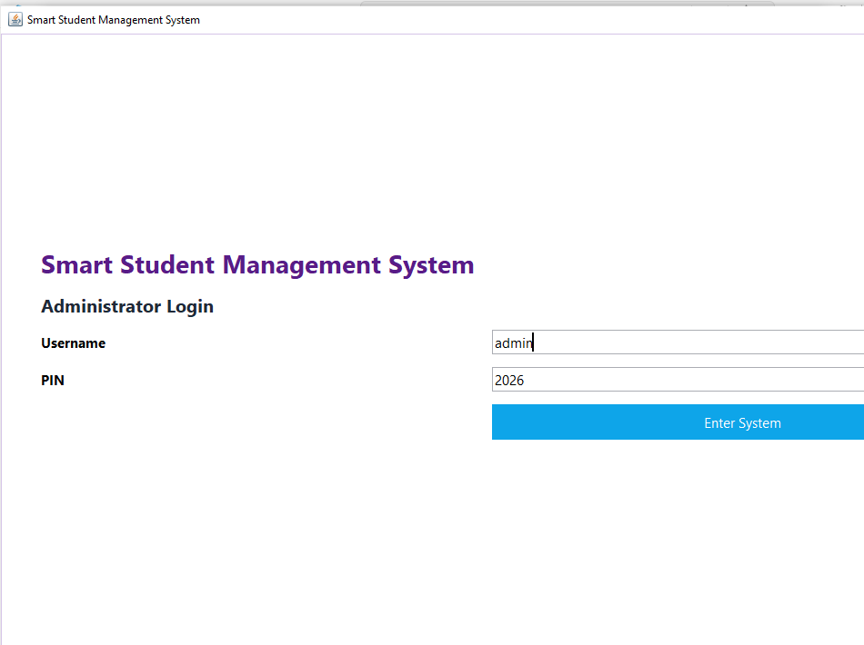

Students Page
Use this page to add, update, delete, search, and select students.
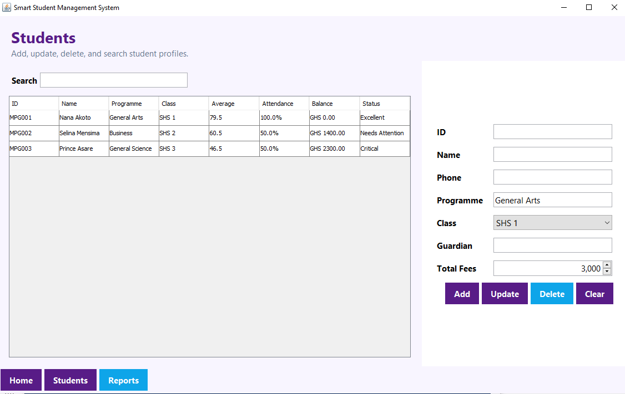

Attendance Page
Select a student first, then record Present or Absent with a note.

Results Page
Select a student first, then add subject code, subject name, and score.

Fees Page
Select a student first, then add payment amount and description.

Reports Page
Use this page to view and export the student's complete smart report.
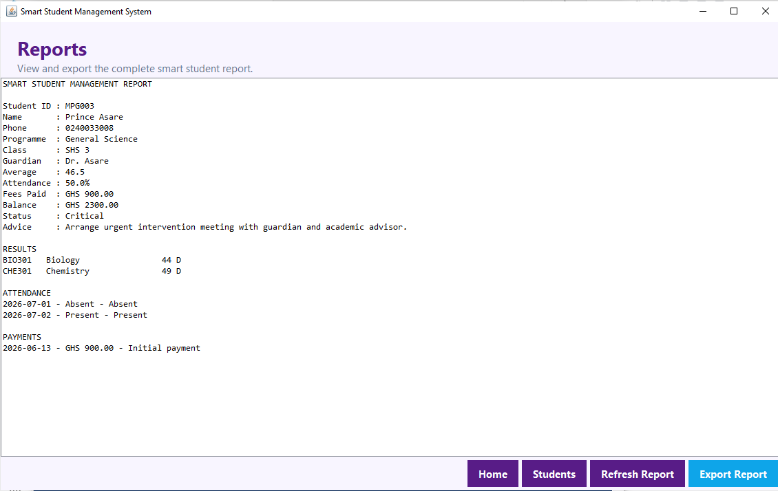

12. Challenges and Solutions
Challenge | Solution
Avoiding a crowded interface | The system uses multiple pages.
Keeping records organized | Data is separated into models for students, attendance, results, and fees.
Showing smart support | SmartStatusService generates status and advice.
Preventing invalid data | InvalidInputException validates entries.
Making navigation clear | Pages include Home, Students, and Reports buttons.

13. Conclusion
The Smart Student Management System demonstrates how Object Oriented Programming can be used to build a practical school management application. The multi-page design makes the program easier to use and separates student profile, attendance, results, fees, and reports.
The project applies encapsulation, inheritance, polymorphism, abstraction, exception handling, collections, modular programming, and event-driven programming.

14. Recommendations
Future improvements may include:
1. Adding database storage.
2. Adding PDF report export.
3. Adding teacher and accountant roles.
4. Adding attendance history charts.
5. Adding SMS or email alerts to guardians.
6. Adding backup and restore features.

15. References
1. Oracle Java Swing Documentation.
2. Oracle Java Platform Documentation.
3. INF811D Object Oriented Programming course materials.
4. Smart Student Management System project source code.

